7COM1079-0901-2025 - Team Research and Development Project

Final report title: An analysis of Mobile Price Classification

Group ID: A18

Dataset number: DS209

Prepared by: [Chiru Sampath – 24067012]
[Sasi Kiran Kumar - 23097477]
[Kondur Vinay Kumar - 24085742]
[Ashok Alla - 24081694]

University of Hertfordshire
Hatfield, 2025

Table of Contents

- Introduction………………………………………………………………………………3
  - Problem statement and research motivation………………………………………3
  - The data set…………………………………………………………………….….3
  - Research question…………………………………………………………………3
  - Null hypothesis and alternative hypothesis……………………………………….3

- Background research…………………………………………………………………….4
  - Research papers…………………………………………………………………...4
  - Why RQ is of interest…………………………………………………………….4

- Visualisation…………………………………………………..………………………….4
  - Appropriate plot for the RQ output of an R script and required supplementary graph/table…………………………………………………………………...……4
  - Additional information relating to understanding the data………………….……5
  - Useful information for the data understanding……………………………...……5

- Analysis………………………………………………………………………..………...6
  - Statistical test used to test the hypotheses and output………………..…………..6
  - The null hypothesis is based on the p-value…………………………..………….6

- Evaluation – group’s experience at 7COM1079………………………………………..6
  - What went well………………………………………………………………….6
  - Points for improvement…………………………………………………………6
  - Group’s time management………………………………………………………6
  - Project’s overall judgement……………………………………………………..6
  - Comment on GitHub log output………………………………………………..7

- Conclusions…………………………………………………………………………….7
  - Results explained……………………………………………………………….7
  - Interpretation of the results……………………………………………………..7
  - Reasons and/or implications for future work, limitations………………………7

- Reference list……………………………………………………………………………8
- Appendices………………………………………….…………………………………..9
- R code used for analysis and visualisation………………………………………….9
- GitHub log output…………………………………………………………………..12

1. Introduction
1.1 Problem statement and research motivation

Smartphone cameras have become one of the most important hardware features influencing purchasing decisions and product positioning. Prior work shows that technical attributes such as memory, battery and display size are strongly linked to smartphone prices and consumer preferences, with camera quality frequently highlighted as a key factor. (Ahmad, 2019; Hwang and Park, 2016).

Manufacturers commonly advertise both rear and front cameras, yet it is unclear to what extent these specifications are configured together across devices. This project focuses on whether smartphones that offer high-resolution primary (rear) cameras also tend to offer higher-resolution front (selfie) cameras within our dataset.

1.2 The Data Set

The dataset contains 1,000 smartphones described by 21 technical columns, including battery capacity, memory, connectivity flags and camera specifications. For our study we focus on two camera measures: front camera resolution (fc) and primary camera resolution (pc), both recorded in megapixels. Our independent variable is front camera resolution (fc), an interval/measurement variable. Our dependent variable is primary camera resolution (pc), which is also measurement data because it represents numeric magnitudes with meaningful differences.
1.3 Research question

This project investigates the following research question:

RQ: Is there a linear relationship between primary camera resolution (pc) and front camera resolution (fc) in smartphones contained in this dataset?

The study aims to quantify the strength and direction of this relationship and interpret its implications for smartphone design and market segmentation.

1.4 Null hypothesis and alternative hypothesis

To address the research question, we test the correlation between the two numeric variables, pc and fc, using Pearson’s product–moment correlation. Let ρ denote the population correlation between primary and front camera resolution.

Null hypothesis (H₀): ρ = 0. There is no linear relationship between primary camera resolution and front camera resolution in the underlying population of smartphones.

Alternative hypothesis (H₁): ρ ≠ 0. There is a linear relationship between primary camera resolution and front camera resolution in the underlying population.

The hypothesis test is conducted at the 5% significance level (α = 0.05).

2. Background research
2.1Research papers

Ahmad (2019) applies a hedonic pricing model to 348 mobile phones in Pakistan and finds that several hardware attributes including RAM, display size, battery capacity and both front and rear cameras carry significant price premia.

This demonstrates that camera specifications are commercially important rather than purely cosmetic features. Hwang and Park (2016) analyse survey data on media use behaviour, showing that consumers who engage heavily with multimedia content tend to prefer smartphones with more advanced hardware specifications, including enhanced camera capabilities.

Kolluru et al. (2025) examine a dataset of 8,277 mobile phones, using exploratory data analysis and clustering to identify distinct market segments. They report that higher-end clusters are characterised by stronger camera specifications for both main and auxiliary modules, alongside larger batteries and higher RAM.

Wahyusari (2025) uses a Kaggle smartphone dataset to predict prices based on technical features, finding that camera specifications, memory and processor speed are among the most influential predictors.

Finally, DXOMARK’s camera testing protocol highlights how image quality now depends on complex interactions between resolution, sensor size and computational photography, reflecting how central cameras have become to device differentiation.

2.2 Why RQ is of interest

Existing studies show that camera specifications are important for both pricing and consumer preferences, and that high-end smartphones typically bundle more advanced features together. However, most work focuses on relationship between camera quality and price or perceived image quality, rather than explicitly quantifying how front and rear camera resolutions co-vary within a large dataset of devices. Prior research rarely reports strength of linear association between these two measures. This project addresses gap by estimating the Pearson correlation between front and primary camera resolution in a structured smartphone specification dataset and interpreting what this suggests about design choices across market segments.

3. Visualisation
3.1 Appropriate graphs for the RQ

The main graph is a scatterplot of primary versus front camera resolution, which shows the linear association between two numeric variables. Histograms for each camera, and a contingency table from grouped categories, are added to show marginal distributions and how phones cluster into low, medium and high-resolution bands.
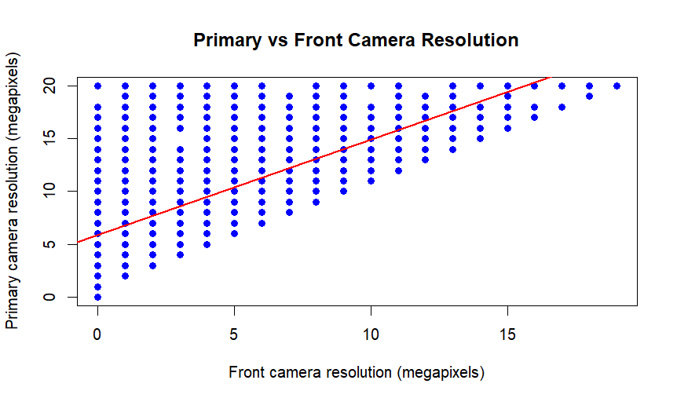

3.2 Additional information relating to understanding the data

The scatterplot and regression line reveal how increases in front camera resolution are accompanied by higher primary camera resolution for devices. Histograms clarify that high-resolution selfie cameras are less common than strong primary cameras. The grouped bar chart visualises the contingency table, highlighting that matching low–low and high–high pairs dominate.

3.3 Useful information for the data understanding

Overall, the visuals show a clear, moderately strong positive relationship between front and primary camera resolution. Most phones with weak front cameras also have modest primary cameras, while models with strong selfie cameras almost always pair them with strong primary cameras. True high-primary, low-front or low-primary, high-front combinations are rare.

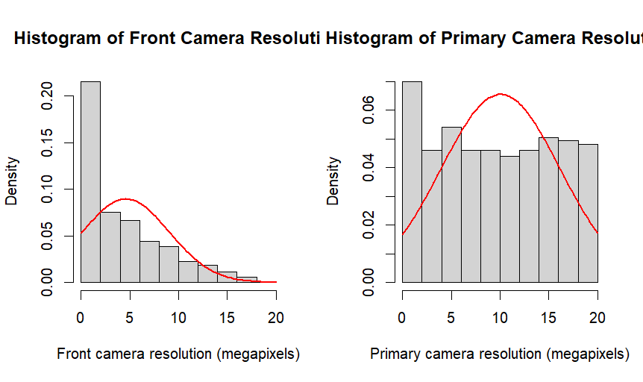

4. Analysis
4.1 Statistical test used to test the hypotheses

Pearson’s product moment correlation test was used because our research question investigates the linear relationship between two numerical variables: front camera resolution (fc) and primary camera resolution (pc). Both variables are interval‑scale measurements recorded in megapixels, making Pearson’s correlation appropriate for assessing the strength and direction of their association. The scatterplot showed a clear linear trend with no extreme outliers, supporting the assumptions required for this test. The analysis was carried out at a 5% significance level.

4.2 Null hypothesis decision and interpretation
The Pearson correlation test produced a strong positive coefficient (r ≈ 0.66) with a p‑value far below 0.05, meaning the result is statistically significant. Because the p‑value is extremely small, we reject the null hypothesis that there is no linear relationship between the two camera resolutions. This indicates that smartphones with higher front camera resolution tend to also have higher primary camera resolution. The confidence interval for r remains entirely positive, reinforcing that this association is unlikely to be due to chance. Overall, the evidence shows a meaningful and consistent upward relationship between the two measures.

5. Evaluation – group’s experience at 7COM1079
5.1 What went well
Our teamwork throughout this project was strong, and we able to divide tasks fairly, so everyone contributed equally. Each member focused on their part while still helping others when needed, which made the process smoother. Communication was consistent, and we kept each other updated on progress. Time management also worked well for us, as we planned our steps clearly and avoided unnecessary delays. Overall, the group collaborated effectively and supported one another throughout the assignment.

5.2 Points for improvement
One area we could improve is writing code more accurately on the first attempt. Sometimes small mistakes slowed us down and required extra checking. We also realised that we need to become more confident using GitHub, especially when organising files and understanding the commit process. With more practice, we could manage version control more efficiently and reduce confusion. Improving these skills would make future group projects smoother and help us work more independently and professionally.

5.3 Group’s time management
Time management was one of our strongest points. We completed most sections of the assignment earlier than expected and did not leave major tasks until the last minute. By staying organised and moving quickly through each stage, we reduced pressure and had enough time to review our work carefully.

5.4 Project’s overall judgement
Overall, the project went very well, and every group member put in great effort. We supported each other throughout the work, which made the whole process more manageable. The outcome reflects the teamwork and commitment everyone showed, and we are satisfied with the quality of the analysis and the report.

5.5 Comment on the GitHub log output
The GitHub log, included in Appendix B, shows clear progress throughout the project with meaningful updates at each stage. It reflects steady development from early data exploration to final analysis. The commits demonstrate how code, visualisations and the written report were improved over time through structured version control.

Three significant commits:
Commit Message: “Initial EDA: load data and summarise fc and pc”
Impact: This commit established the foundation for the analysis by preparing the dataset and confirming the variables required for our research question.

Commit Message: “Add scatterplot and Pearson correlation analysis”
Impact: This update introduced the main statistical test and visual output, directly addressing the research question and forming the core of our findings.

Commit Message: “Final proofreading and figure captions updated”
Impact: This final commit improved clarity, corrected labels and refined the report, ensuring the submission met academic standards and was ready for assessment.
6. Conclusion
6.1 Results explained
The analysis showed a clear link between the two camera resolutions. The Pearson test gave a moderately strong positive correlation, and the very small p‑value confirmed that this pattern is statistically meaningful. The scatterplot supported this result, as the points formed a steady upward trend. Overall, the findings show that phones with higher front camera megapixels usually also have higher primary camera megapixels, indicating a consistent relationship across the dataset.

6.2 Interpretation of the results
These results directly answer the research question by showing that the two camera features tend to increase together. This suggests that when manufacturers design a phone with a good front camera, they usually pair it with a strong primary camera as well. In a broader sense, it reflects how the market values balanced camera performance. For users, this means that a phone advertised with a better selfie camera will often deliver better general photography too.

6.3 Future work, implications and limitations
One limitation is that the dataset includes only camera resolution and no other factors like sensor size, brand or software processing, which also affect camera quality. Future studies could expand the analysis by including price ranges, phone categories or real‑world image performance to gain a more complete understanding of how camera systems are developed.

7. Reference
Ahmad, W. (2019) ‘Pricing of mobile phone attributes at the retail level in a developing country: Hedonic analysis’, Telecommunications Policy, 43(4), pp. 299–309.
DXOMARK (2025) ‘Smartphone camera image quality test protocol: A closer look’.
Available at: https://www.dxomark.com/smartphone-camera-image-quality-test-protocol-a-closer-look/ (Accessed on 04/12/2025).
Hwang, D. and Park, S. (2016) ‘The effect of media use behavior on the preference for smartphone specifications’, European Scientific Journal, Special Edition (May), pp. 447–460.
Kolluru, V., Ganguly, R. and Nethala, S. (2025) ‘Comprehensive analysis of mobile phone specifications: Trends, clustering, and market insights’, in Feed Forward. IEEE Computer Society, Santa Clara Valley Chapter.
Wahyusari, R. (2025) ‘Predicting smartphone prices based on key features using data mining algorithms’, International Journal for Applied Information Management, 5(2), pp. 73–85.

8. Appendices
A.1 eda_summary.R

A.2 Histogram.R
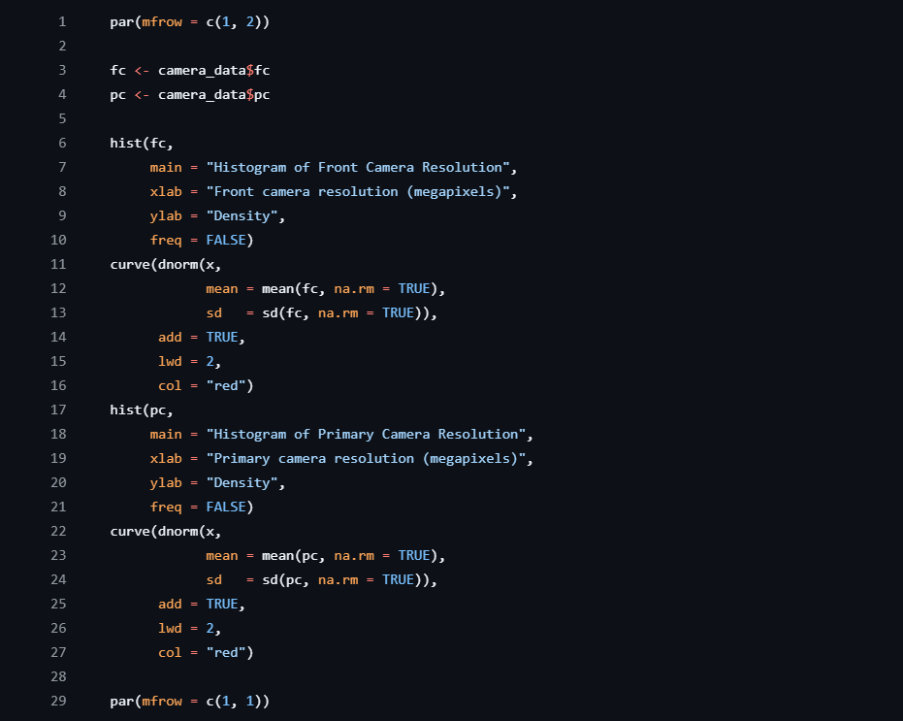
A.3 scatter_correlation.R
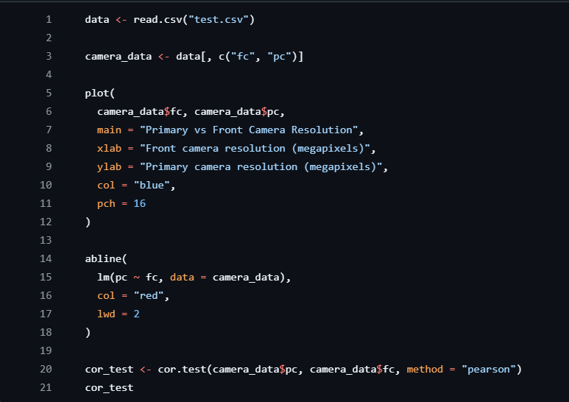

A.4 contingency_barchart.R
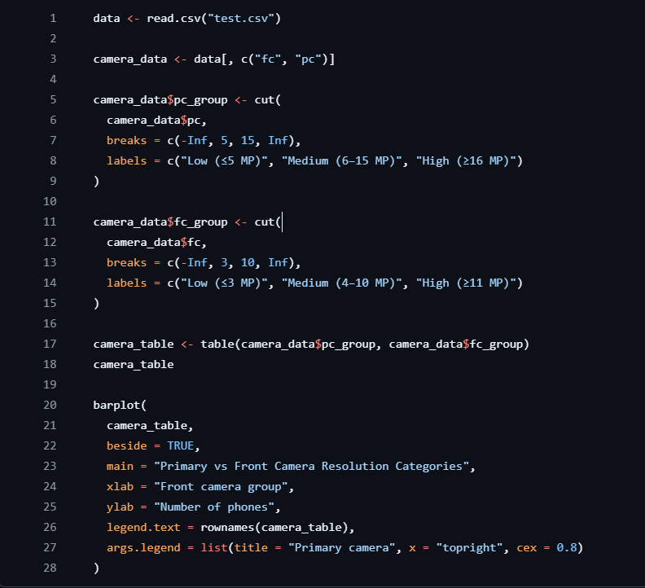

B. GitHub log output






